LED UV light for industrial applications
ipf adds new, robust alternative solution to its range

In view of the announced EU ban on conventional UV fluorescent lamps containing mercury, manufacturers are increasingly discontinuing such solutions. As UV light is still required in many industrial sectors, ipf has added the EM300U21 LED UV light to its product range.

The round UV/A LED light has protection class 3 and is operated with a protective low voltage of 24V DC. The robust housing is made of aluminum with a clear front screen made of scratch resistant PMMA (protection class IP67) and has a diameter of 30mm and an overall length of 261mm (light field length 198mm). The radiation angle of the EM300U21 is 120°. The electrical connection is made using an M12-connector.

The new solution from ipf is ideal for all industrial applications in which conventional UV fluorescent lamps were previously used. This applies in particular to crack testing on components using fluorescent substances, the drying of paints, coatings, silicones, sealants or adhesives as well as for large-area UV LED curing of coatings and products manufactured using additive processes (3D printing).

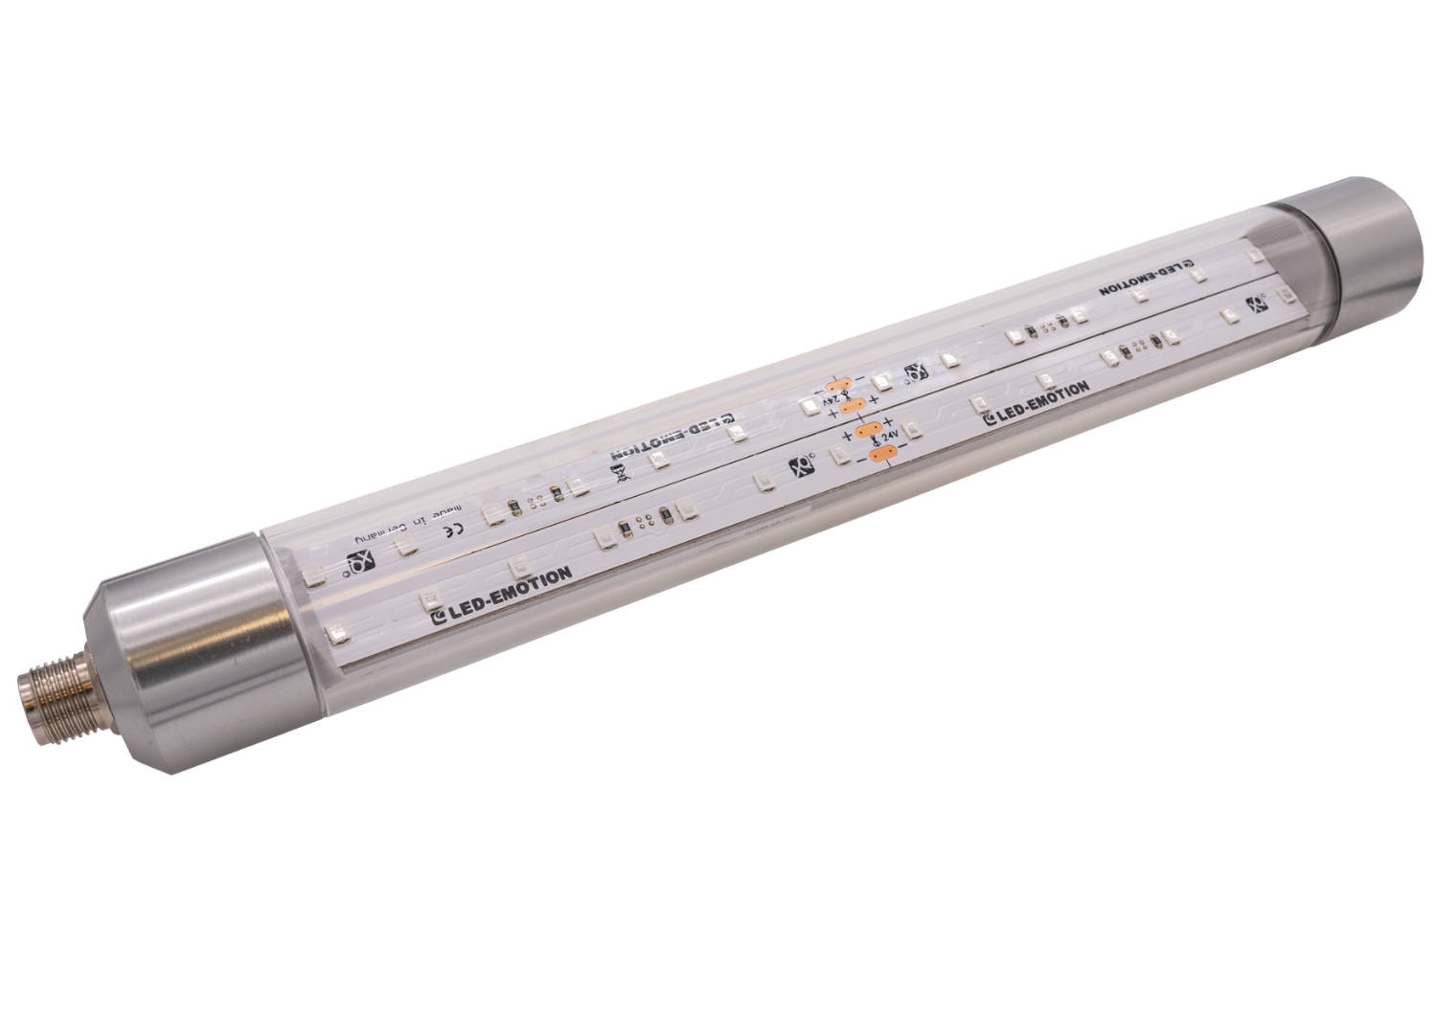

Caption: With the EM300U21 UV/A LED light, ipf has added a real alternative to conventional
UV fluorescent lamps in its product range. (Image: ipf electronic gmbh)

ABOUT IPF ELECTRONIC
Sensors of the highest quality
When HIGH-TECH becomes HIGH-END

We have stood for high-performance sensors in automation technology in the German-speaking markets for over three decades. We prioritize the highest level of quality and have our own production at our headquarters in Altena in Sauerland.
We are ipf electronic and do more than just our job. We think outside the box, create innovative, sustainable solutions, and remain approachable. We are based in Sauerland, one of the most innovative areas in Germany. Our products are precise, intelligent, technologically well-engineered and versatile. Our 140 employees live and breathe service, even outside of normal business hours.
Our wide range of products, great problem-solving skills and strong focus on service make us a unique top-supplier of industrial sensor technology. Permanent research and development play an equally substantial role as the education and training of employees and management. Our company, which was founded in 1982, is managed today by the family in the second generation. We apply special standards in environmental protection and sustainable resource management.

CONTACT
ipf electronic gmbh
Rosmarter Allee 14
58762 Altena
Germany
info@ipf-electronic.com
www.ipf-electronic.com


PRESS CONTACT
Martinus Menne
Waldweg 8 ● 57489 Drolshagen
Germany
Tel +49 2761 8288861
mm@technikredaktion.de
www.technikredaktion.de

